SCOTTISH VOLLEYBALL
AIDE FOR SCORERS – Key Points
(Based on common errors)
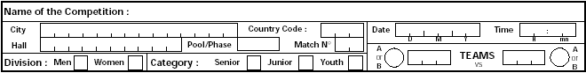
- Complete the header

- Name of competition
- City, Hall and Country code -Trigram for Country
- Date and advertised start time
- Pool/Phase e.g. Division, Cup Round etc
- Match number from fixture schedule/website

- Division (gender) – Insert X in the approp. box
- Category – Insert X in the appropriate box
- Teams – Use the appropriate Trigram – home team on left or if a neutral venue as listed in match schedule

Note Leave the circles A or B blank by the team name until after the coin toss - (court A on left side of scorer).

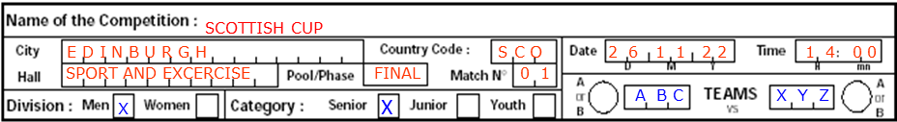

2.Complete Team Listing

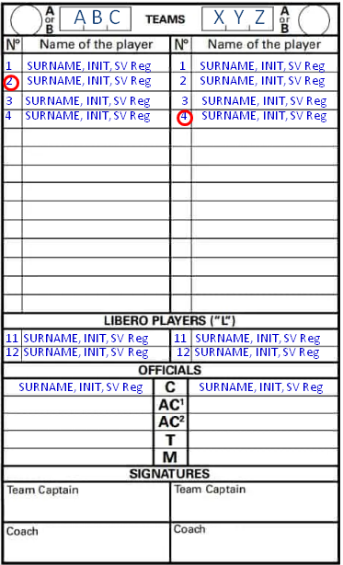
- A and B will be empty until after the coin toss
- Circle the captains
- If possible, list players in numerical order.
- Must have SV registration number
- Maximum 12 Players on list (including Liberos)
- Captains and coaches must sign before match starts

When the scorer receives the line-up sheets, it is good practice to ensure that the payers listed are on the score sheet. If they are not listed, inform the second referee immediately.

- Substitutions
Record the scores of both teams at time of the substitution (Team completing the substitution is first). When the starting player returns to the court, record the scores of both teams and circle the number of the player leaving the court (to show they can’t legally return to court this set).
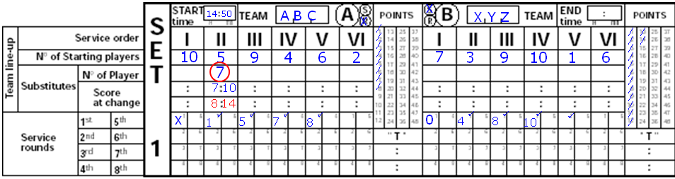
- End of Set
- Write the exact time at the end of the set into the END time box.
- Cancel the points not reached by both teams in the columns of POINTS
- Circle the last points recorded in the Service Rounds (Circles in the tally section are PENALTY points only)
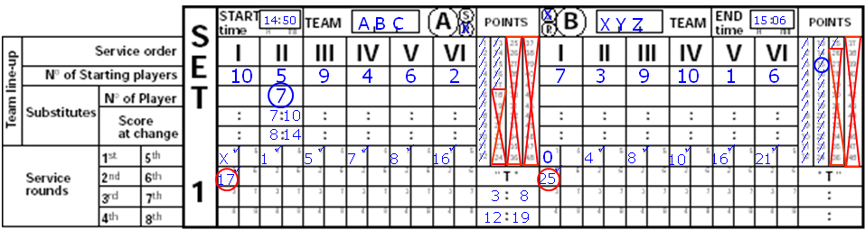
- If a set is won by a receiving team, the last point must be recorded and circled without crossing out the Service Round number

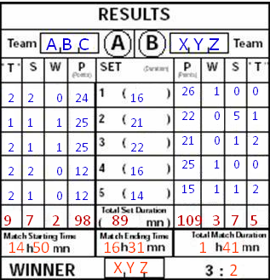

- End of Match
- Complete the results box
- The final row is for the totals of Time outs, subs etc
- Record start, end times and total duration of match
- Record the winner of the match
- There should be 6 minutes difference between set duration and match time for a 3 set match, 9 minutes for 4 set match and 12 minutes for a 5 set match

